RFP Grab-n-Go Food Services 05-28-2025-DJ Vendor Questions
- Please clarify, Under Appendix D, item 2, Term of Statement of Work, reads “Vendor will move medical equipment, staff belongings, breakroom and office contents to Folsom MOB facility,” what is Shef Madres responsibility?

- You can disregard that line in item 2 of the SOW. It was for a different RFP and should not have been included. Updated SOW template has been added to RFP website. Thank you for pointing this out.

- What is the maximum production/output daily?

- We are anticipating roughly 300-500 units per day with potential growth with the opening of new retail spaces in the future.

- What methods and/or systems are currently used to track sustainability efforts and energy conservation?

  - We will need a quarterly excel spreadsheet with any locally sourced products or ingredients used to produce the meals. Please see the sample screen shot below: Pivot excel spreadsheet to denote Locality or sustainability certificate.

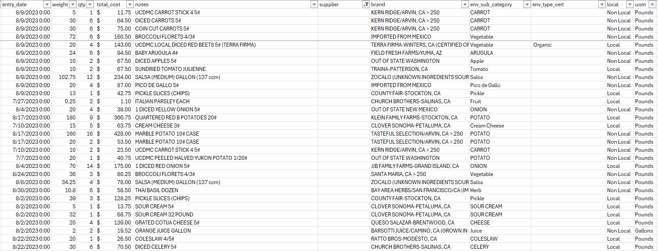

- Keeping in line with the goal of sustainability and reduced waste, what shall be the SOP to manage shrink/waste items, not sold on campus? What role, if any, does Shef Madres have in managing waste once items have been delivered to client?

  - We currently partner with Copia for any eatable product donations. Shef Madres does not have any role nor responsibility of any products after being delivered to any of our locations.

- What options are available for substitution of product when an item is not available due to weather, seasonal changes, farm issues outside our control?

  - We understand seasonality and that locally sourced product can a times gap due to weather, crops etc. Substitutions are allowed under those circumstances (example: avocados from Mexico) and those are to be noted on the local sustainable quarterly product reports displayed above.

- What will be the production requirements placed on Shef Madres during labor action/strikes? Will we negotiate those requirements outside of this contract?

  - I believe that union actions, such as strikes, would yield the opportunity for "outside contract requirements" given the short notice and one-off nature of the actions. These orders may yield numbers up to 6,000 units per day. These are not required through this RFP, but consideration of this type of scenario would be appreciated.

- What are the current sales breakdowns by type? How many individual salads, sandwiches and wraps are sold, each day, and how do you project those numbers?

  - Current production break downs are reflected below (roughly 500 total units daily):
  - We offer five (5) different salads totaling 150-200 units per day
  - We offer nine (9) different sandwiches totaling 250-300 units per day

- What are the terms/duration of the contract and how often will the contract be renegotiated?

  - Contracts will start with a 2-year period with a respective service contract assigned to a PO number, which will be extended thereafter. PO will be funded and renewed annually to disburse payments for all invoices.

- Can the contract be terminated by either party and if so, what are the requirements/conditions to do so?

  - Contracts are determined by the needs of our food program. Any contract termination will follow the UC Terms and Conditions process.

